Addis Ababa University
Data Science and Cloud Computing in Bioinformatics

Module 7

High-Performance Computing (HPC)

Assignment 7

Name: Beyene Chalchisa
ID N_{O}: GSR/4596/18

Part A — Understanding the HPC Environment

Answer:

I have understood HPC Environment on my private ubuntu account. Because I have no university HPC account’s some question was cannot proceed without HPC account so that shown by it’s inscription and ideally.

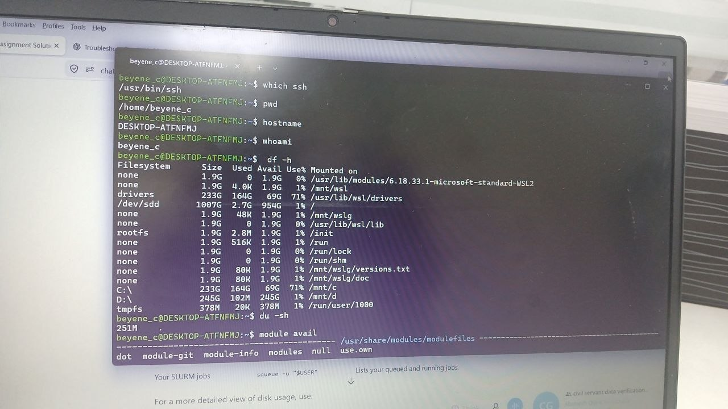

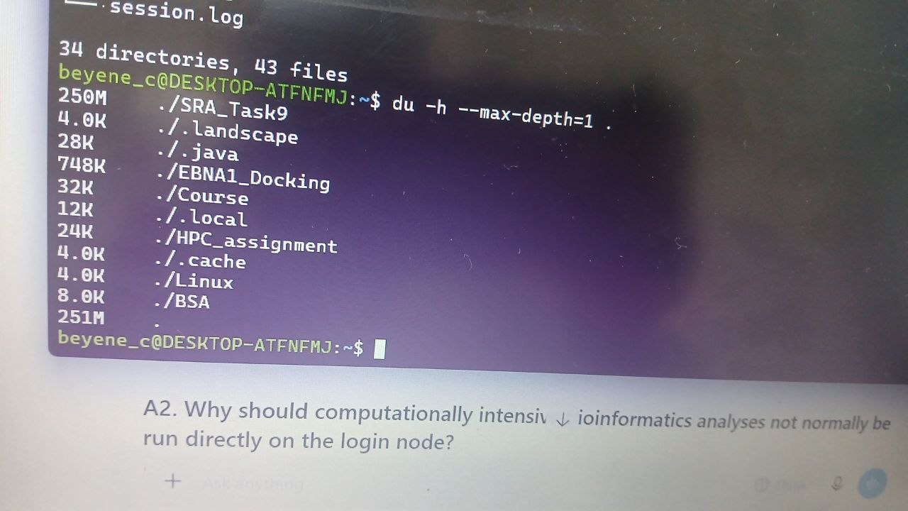

A1. What is the purpose of a login node?

Answer:

A login node is the entry point to an HPC cluster. Users connect to it to:
- log in to the cluster;
- create and organize files;
- edit scripts;
- compile programs;
- submit jobs to the scheduler;
- monitor jobs;
- manage software environments.

A2. Why should computationally intensive bioinformatics analyses not normally be run directly on the login node?

Answer:

Login nodes are shared by many users and are intended for lightweight activities, such as editing scripts, managing files and submitting jobs.

Running computationally intensive analyses on a login node can:
- Consume CPU and memory needed by other users.
- Slow down the login node.
- Interfere with cluster administration.
- Violate the institution's HPC usage policies.

A3. What is the purpose of a compute node?

Answer:
- A compute node is a machine in an HPC cluster that provides CPU cores, memory and other computing resources for executing computational workloads.
- Bioinformatics applications such as FastQC, BWA, Minimap2 and RNA-seq alignment tools can run on compute nodes after resources have been allocated by the scheduler.

A4. What role does SLURM play between the user and compute nodes?

Answer:
- SLURM (Simple Linux Utility for Resource Management) is a workload manager and job scheduler.
- It receives job submissions, manages resource requests, schedules jobs and allocates available compute nodes.

B. Create a Project Directory

1, To directory structure
- We use “mkdir -p HPC_assignment/{data,scripts,logs,results,tmp}” inscription

2, To Verify the structure
- Use “tree HPC_assignment” or use “find HPC_assignment -type d”

3, Why is separating data, scripts, logs and results useful for reproducible bioinformatics?
- Separating project files into directories improves organization, reproducibility and error management.
E.g., data/: Stores input datasets, such as FASTQ files and reference genomes.

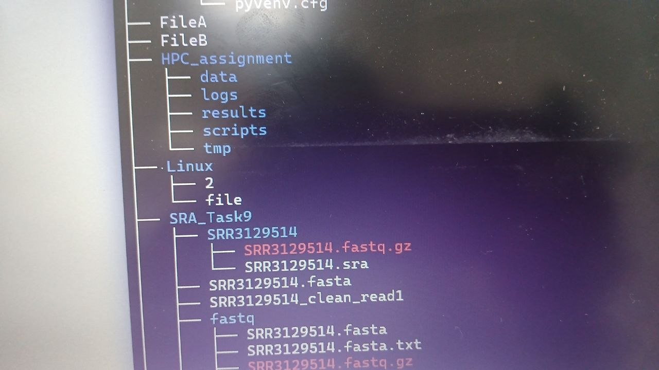

Part C — Software Environment

C1, Investigate available software
- List the available software modules:
We can use in ubuntu:
module avail fastqc
module avail samtools
module avail bwa
module avail minimap2
module avail python

C2, Load a software module
- For example: Loading “module load samtools”

What is an environment module?

Answer:
- An environment module is a software-management system used on HPC clusters to configure the user's environment for a particular software package

Why is recording the exact software version important?

Answer:
- Recording the software version is important for reproducibility because different versions can produce different results, change default parameters,
- For example, recording the exact version of Samtools allows another researcher to identify the software used to process a BAM file.
C3. Compare modules, Conda and containers
Feature | Environment Modules | Conda | Containers
Main purpose | Manage cluster software | Create software environments | Package software + dependencies
Version control | Good | Very good | Very good
Isolation | Moderate | High | Very high
HPC use | Very common | Common | Increasingly common
Part D — Your First SLURM Batch Job
- The assignment requires a script named “first_job.sh”
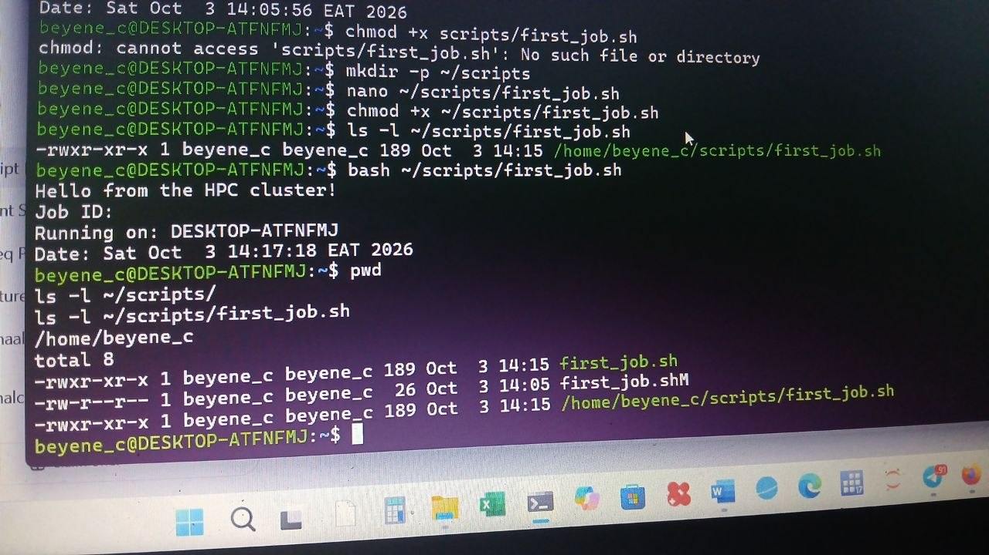
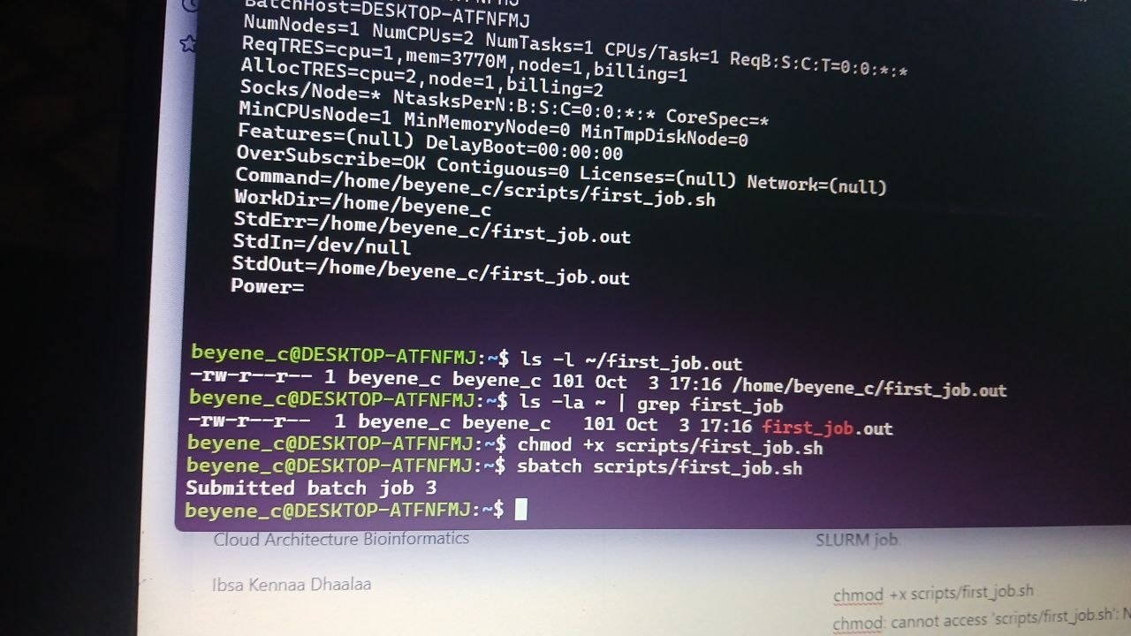

Part E — Monitoring a SLURM Job
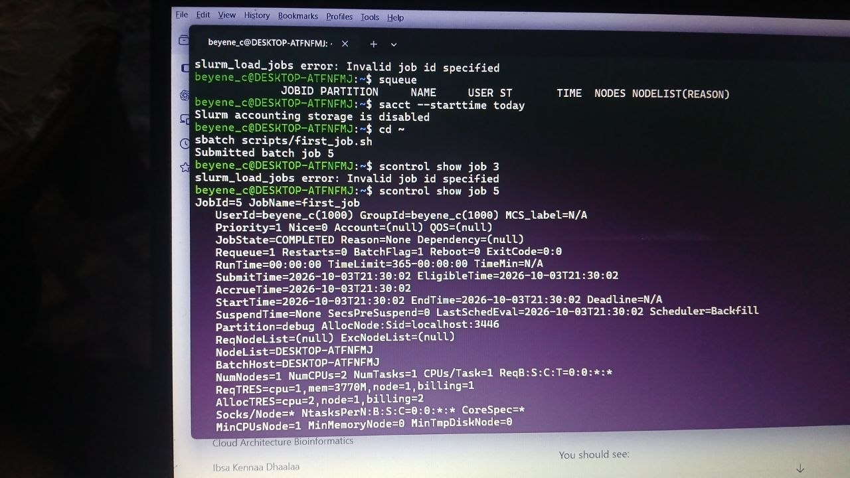
- The assignment recommends squeue, scontrol, and sacct
Explanation
State | Meaning
PENDING | Job is waiting for resources
RUNNING | Job is currently executing
COMPLETED | Job finished successfully
FAILED | Job ended unsuccessfully
CANCELLED | Job was cancelled
TIMEOUT | Job exceeded its requested time
OUT_OF_MEMORY | Job exceeded its allocated memory
Wall time: is the actual elapsed time from the start of a job until it finishes.
CPU time: is the amount of processor time consumed by the program.
For example, if a program runs for 10 minutes using 8 CPU cores:
- Wall time = 10 minutes
- Approximate CPU time = 10 × 8 = 80 CPU-minutes

Part F — Multithreaded Bioinformatics Job
- Write a SLURM script requesting:
8 CPU cores
16 GB RAM
2 hours
Answer:
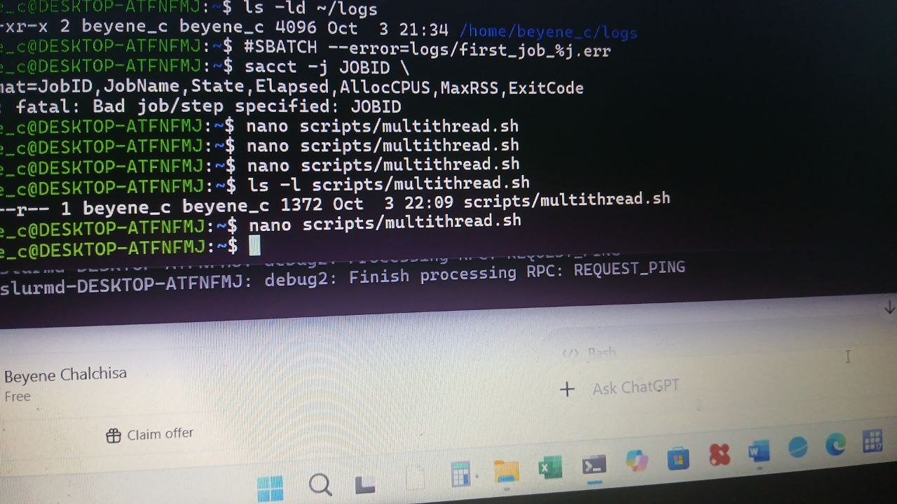
F1. What happens when you ask for 32 CPUs, but the application runs with only 1 thread?
Answer:
- Most of the 32 CPUs get wasted. This is due to low resource usage efficiency since the job gets 32 CPUs but utilizes only one.
F2. What will happen when SLURM assigns 4 CPUs but your application uses 32 threads?
Answer:
- The application tries to use more threads than available CPUs.
It leads to:
- CPU oversubscription;
- CPU competition;
- inefficient use of resources.
F3. Why use this?
Answer:
- Because $SLURM_CPUS_PER_TASK automatically matches the number of CPUs requested from SLURM.
Part G — SLURM Job Array
.You have 10 biological samples.
Answer:
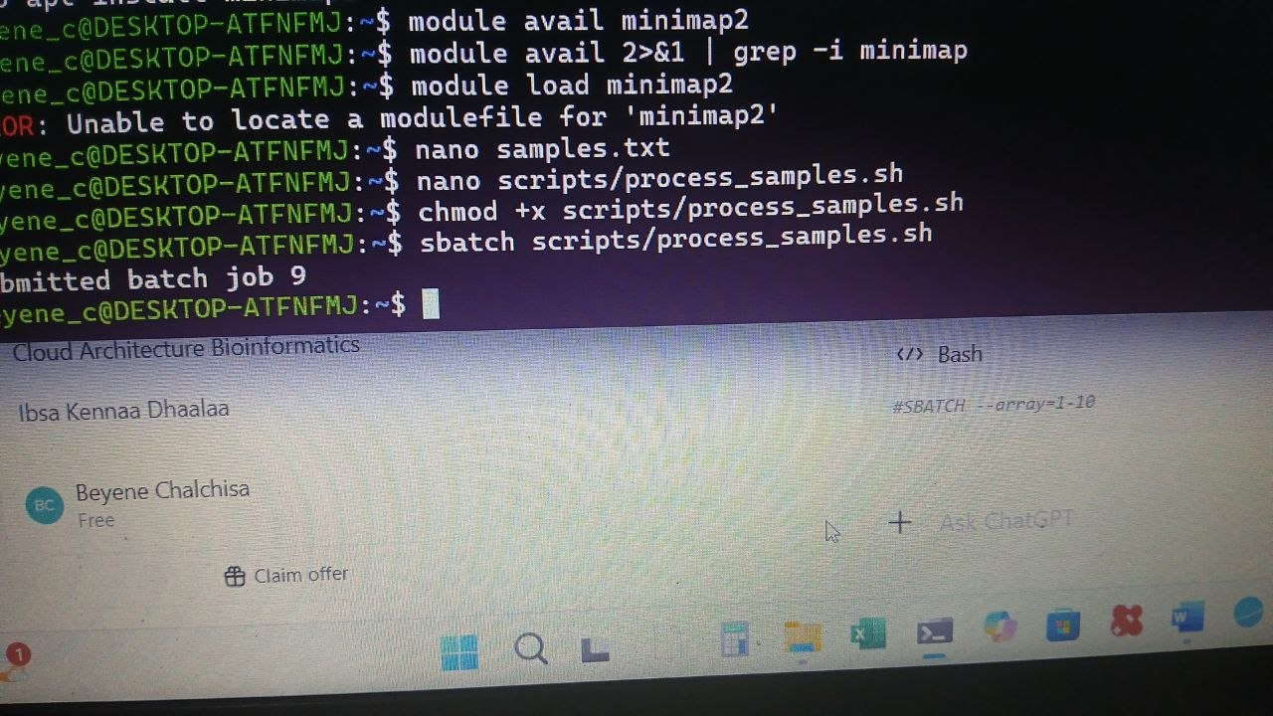

G1. What is a SLURM job array?
Answers: 1-10
- A SLURM job array is a collection of related jobs submitted together using a single job submission.

G2. Why are arrays useful for FASTQ processing

Answers
Each Array has independent samples
- Arrays are useful because biological datasets often contain many independent samples.
G3. 8 CPUs × 10 simultaneous tasks
Answer:
- Maximum CPU allocation = 80 CPUs.
G4. 16 GB RAM × 10 tasks = 160 GB RAM
Part H — Controlling Array Concurrency
Imagine you have:
1,000 samples
Submitting 1,000 simultaneous tasks may overload shared resources.
Modify the array directive to allow a maximum of 20 tasks to run simultaneously.

Ansewrs:

CPU calculation
Each task:8 CPUs
Maximum simultaneous tasks:20
Therefore: 20 × 8 = 160 CPUs
Maximum simultaneous CPU request = 160 CPUs.

RAM calculation
Each task: 24 GB RAM
Therefore: 20 × 24 GB = 480 GB
Maximum simultaneous memory request = 480 GB RAM.

Why limit concurrency?
Answer:
- Limiting concurrency prevents a very large number of jobs from consuming all cluster resources simultaneously. So, It can:
- reduce resource contention;
- prevent cluster overload;
- improve scheduling fairness;
- avoid excessive memory/CPU demand;
- allow other users' jobs to run.
Part I — Job Dependencies
The workflow is: FASTQ Alignment BAM sorting Variant calling
Variant calling must not start until alignment and sorting have completed successfully.
Then the SLURM dependency:
Let first job ID is,
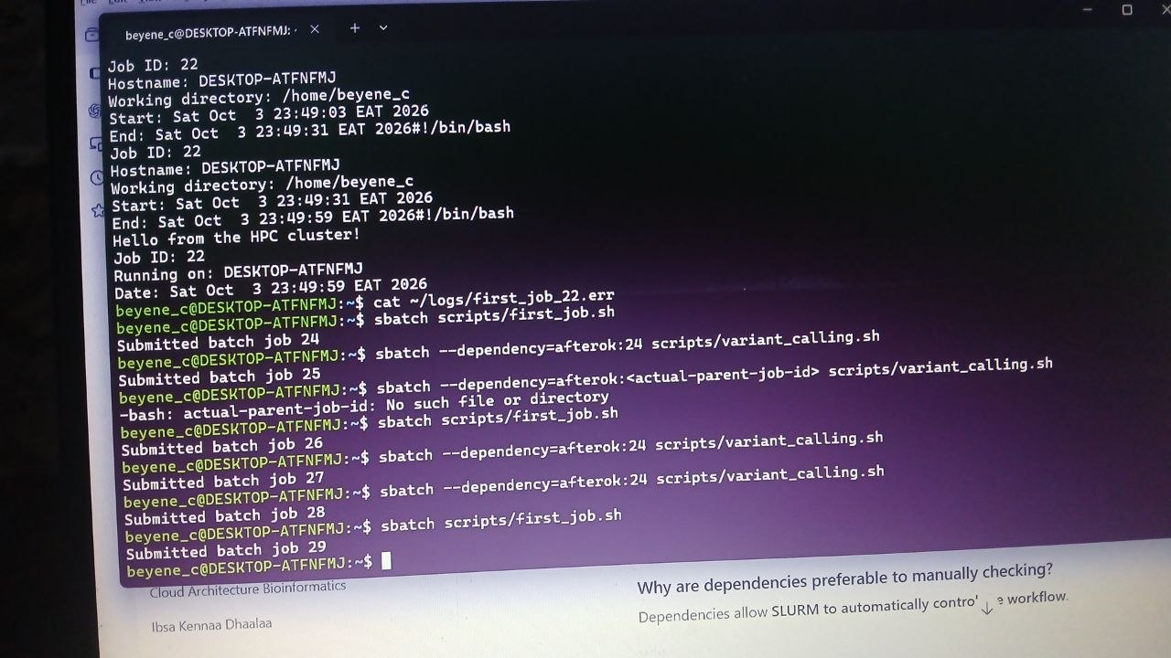

Why are dependencies preferable to manually checking?
Answer:
- Dependencies allow SLURM to automatically control the workflow.
Part J — Troubleshooting
Answer:
- The job used almost all of the 16 GB of allocated memory. The actual memory requirement may have briefly exceeded the 16 GB limit, causing SLURM to terminate the job with an OUT_OF_MEMORY state.
Reasonable next action: Increase the requested memory moderately and rerun the job. For example:
#SBATCH --mem=20G

Scenario 2 — TIMEOUT
Answer:
Before resubmitting, investigate:
- Actual runtime — determine how long the program needs to finish.
- CPU utilization — check whether the allocated CPUs are being used efficiently.
- Memory usage — determine whether memory is sufficient.
- Input data size — larger datasets may require more processing time.
Scenario 3 — Excessive resource request

Why is this poor HPC practice?
- Because the student requested far more resources than the program actually used.
The job reserved:
- 64 CPUs but had very low CPU utilization;
- 256 GB RAM but used only about 12 GB;
- 48 hours but completed in only 35 minutes.
This unnecessarily reserves cluster resources and can:
- reduce resource availability for other users;
- increase queue times;
- decrease overall cluster efficiency;
- make inefficient resource allocation more likely.
Part K — Final Bioinformatics Workflow Design
Convert SRAs to FASTAQ paired-end RNA-seq samples
Given: each alignment requires approximately:
8 CPUs
24 GB RAM
90 minutes

- Use a job array
- Because samples can generally be processed independently at the sample level, use a SLURM array.
- CPUs per task
8 CPUs
#SBATCH --cpus-per-task=8
- RAM per task
24 GB
SLURM: #SBATCH --mem=24G
- Wall time
#SBATCH --time=02:00:00
The array size should correspond to the number of biological samples.

Array size

The array size should correspond to the number of biological samples.
- Maximum concurrent tasks
#SBATCH --array=1-100%10
10 simultaneous tasks
RAM:
10 × 24 GB = 240 GB
Alignment SLURM Script
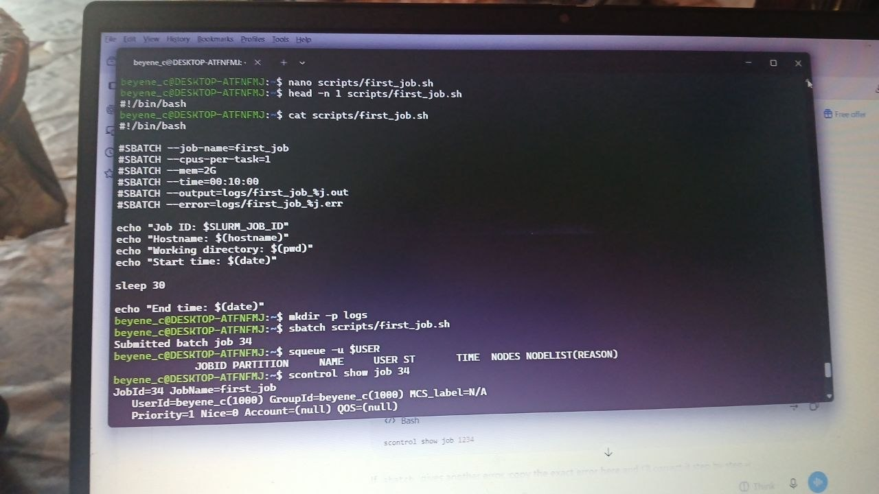
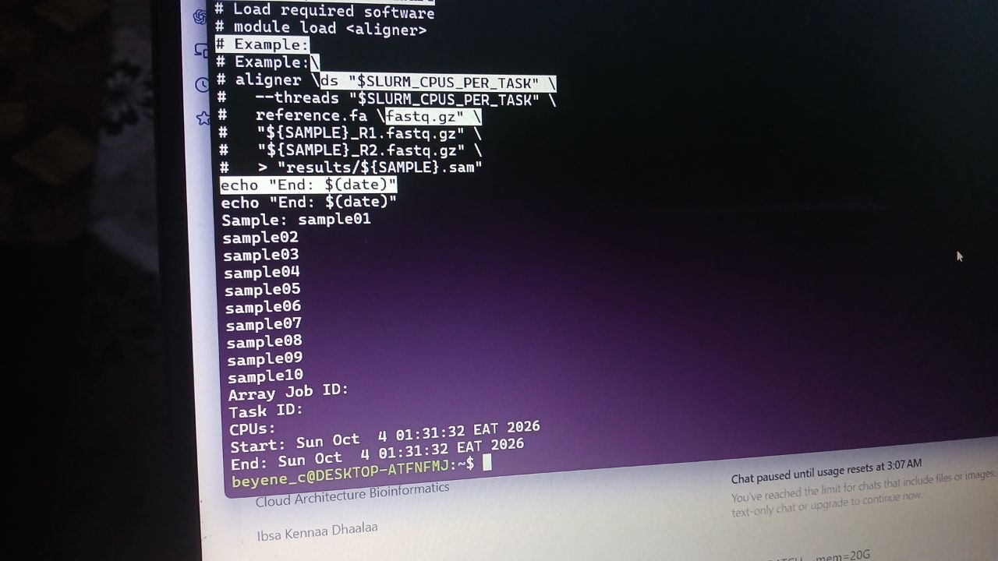
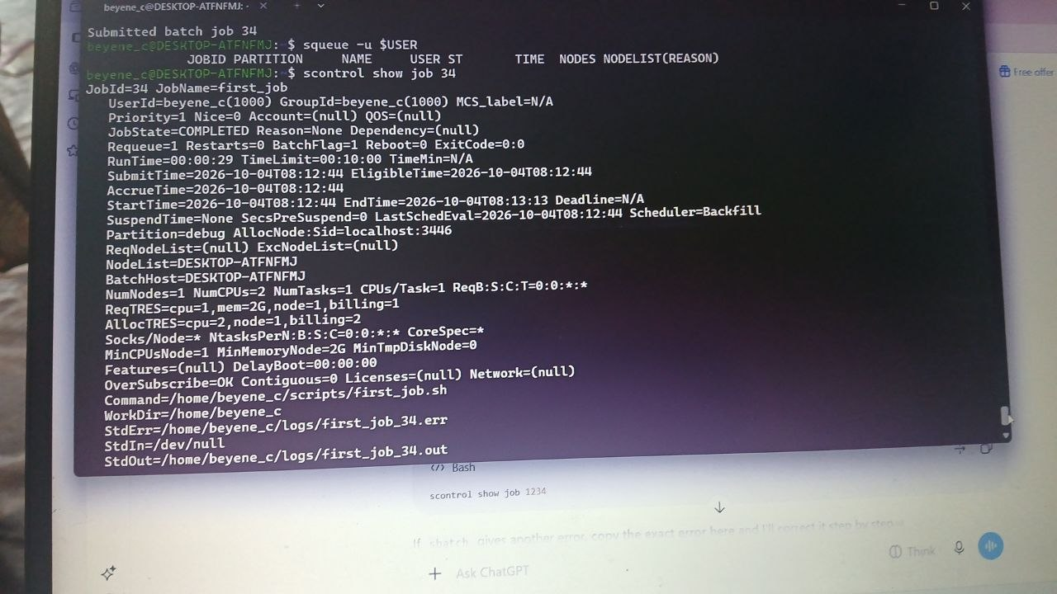

Storage problem: Slurm accounting storage is disabled
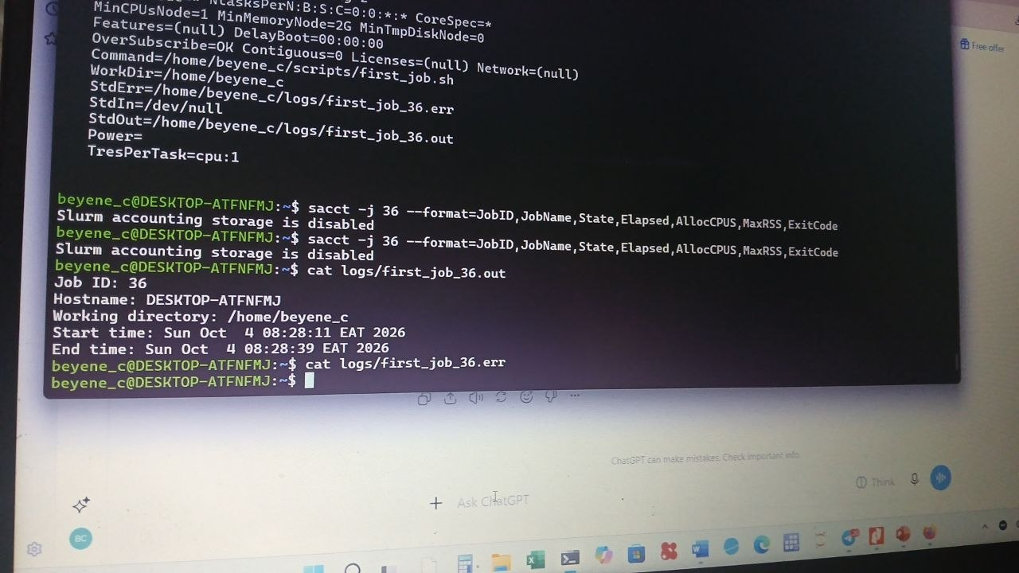
7, Output/Error Log Organization
- The error is because your local WSL Slurm node only has about 3.7 GB of configured RAM, but the assignment asks for 24 GB per alignment task.
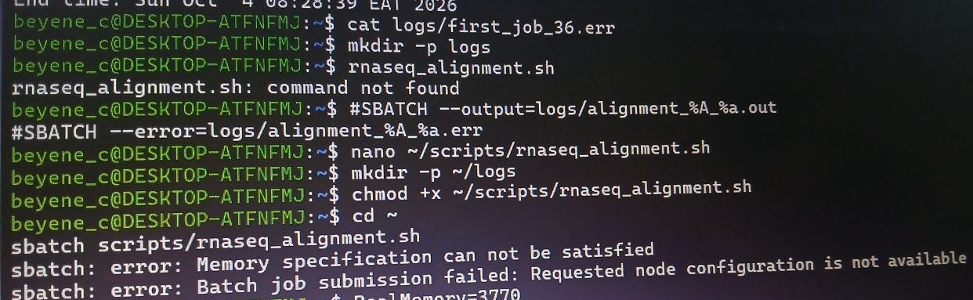

8, Software Environment
- I would use a controlled software environment so that all array tasks use the same software versions.
Because your local WSL practice cluster does not have those bioinformatics software modules installed.
module load STAR was runed
- module load STAR
- module load SAMtools
- module load FastQC
- so muddle can not loaded because of HPC account absence
- 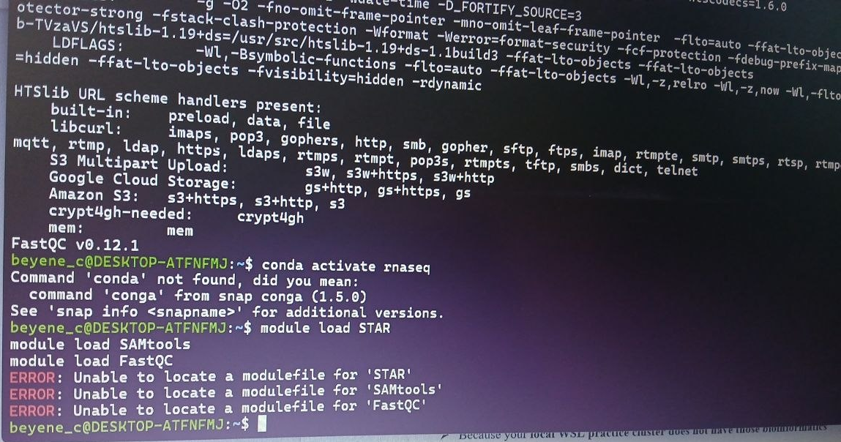

9, Result Directory Structure
- The directory structure was constructed as the following
RNAseq_project/
├── data/
│ └── fastq/
│ ├── sample01_R1.fastq.gz
│ ├── sample01_R2.fastq.gz
│ ├── sample02_R1.fastq.gz
│ └── sample02_R2.fastq.gz
│
├── reference/
│ ├── genome.fa
│ └── genome_index/
│
├── metadata/
│ └── samples.tsv
│
├── scripts/
│ └── rnaseq_alignment.sh
│
├── logs/
│ ├── alignment_12345_1.out
│ ├── alignment_12345_1.err
│ ├── alignment_12345_2.out
│ └── alignment_12345_2.err
│
├── results/
│ ├── aligned/
│ │ ├── sample01/
│ │ ├── sample02/
│ │ └── ...
│ ├── qc/
│ └── statistics/
│
└── docs/
└── software_versions.txt

10. How you Would Monitor Failures?
Answer:
I would monitor the job array while it is running using:
- For a particular array: squeue -j JOB_ID
- I would inspect the individual error logs by:cat logs/alignment_12345_1.err
- I would also check the output logs by:cat logs/alignment_12345_1.out
- If Slurm accounting is available, I would use: sacct -j JOB_ID

11. How you Would Ensure Reproducibility?

Answer:
If HPC account available, I would ensure reproducibility by recording:
- Input data: sample IDs and FASTQ filenames.
- Reference genome: genome version and annotation version.
- Software versions: STAR/HISAT2, SAMtools, FastQC, etc.
- Parameters: all alignment and filtering parameters.
- HPC resources: CPUs, RAM, wall time, and array settings.
- Scripts: keep all analysis scripts in the scripts/ directory.
- Environment: save the Conda environment or module versions.
- Logs: preserve .out and .err files.
- Metadata: keep a sample sheet describing every sample.
- Version control: use Git to track changes to scripts.

